**What is Value Chain Analysis?**

Value chain analysis is a strategic process where a firm evaluates its internal activities to identify how each contributes to the firm's competitive advantage. The ultimate goal of a value chain analysis is to pin down the practices and processes that differentiate a firm from its competitors — for better or worse.

Value chain analysis is a way for businesses to analyze the activities they perform to create a product. Once the activities are analyzed, a business can use the results to evaluate ways to improve its competitive advantage.

While one of the goals of value chain analysis is to improve operational efficiency, its final and most important goal is to establish an advantage over competitors.

**Value Chain Analysis Steps**

1. Determine the business' primary and support activities.
2. Analyze the value and cost of the activities.
3. Refer to your competitors' value chains.
4. Understand your customer base's perception of value.
5. Identify opportunities to gain a competitive advantage.

### ****1. Determine the business' primary and support activities.****

Together, the primary and support activities make up the value chain. They include each action required in developing a product or service, from raw material to final product.

**2. Analyze the value and cost of the activities.**

The team tasked with creating the value chain analysis should brainstorm ways each activity provides value to customers and the business as a whole. Compare the activity to the competitive advantage you're trying to achieve and see if it supports the goal.

After the value analysis is complete, look at the cost of the activities. Is the activity labor-intensive? How much does X raw material cost?

Asking similar questions will help identify which activities are cost-effective and which are not. This is where areas for improvement can be identified.

### ****3. Refer to your competitors' value chains.****

A value chain analysis improves your competitive advantage, so any business that conducts one should keep that information close to the chest. In all likelihood, you won't happen upon a nuanced, in-depth picture of your competitors' primary and support activities.

Still, you can get some concept of your industry peers' value chains through competitive benchmarking — using relevant metrics to compare your company to competitors’. The practice is multifaceted and is used for three primary functions:

* **Strategic benchmarking**: comparing business models and strategies.
* **Process benchmarking**: comparing business and operational processes.
* **Performance benchmarking**: comparing business outcomes based on a set of metrics.

**4. Understand your customer base's perception of value.**

The customer is always right. So however valuable your customers perceive your product or service to be is exactly how valuable it actually is. Customer perception might be the most crucial factor in framing your competitive advantage, so you need to have a pulse on it.

Customer surveys, digging into any, and doing anything that will cue your target market’s perception of you are central to conducting a fully realized value chain analysis.

**5. Identify opportunities to gain a competitive advantage.**

Once the value chain analysis is complete, the primary stakeholders in the business can see an overview of where the business is excelling and where improvements can be made operationally.

Begin with the improvements that take minor changes and provide high-impact results. After the easy wins are identified, you and your team can tackle the bigger challenges that might be hindering efficiency.

The value chain analysis gives businesses a clear idea of how to adjust their actions and processes to provide the most value to their target market and increase profit margins for the company.

Case Study:

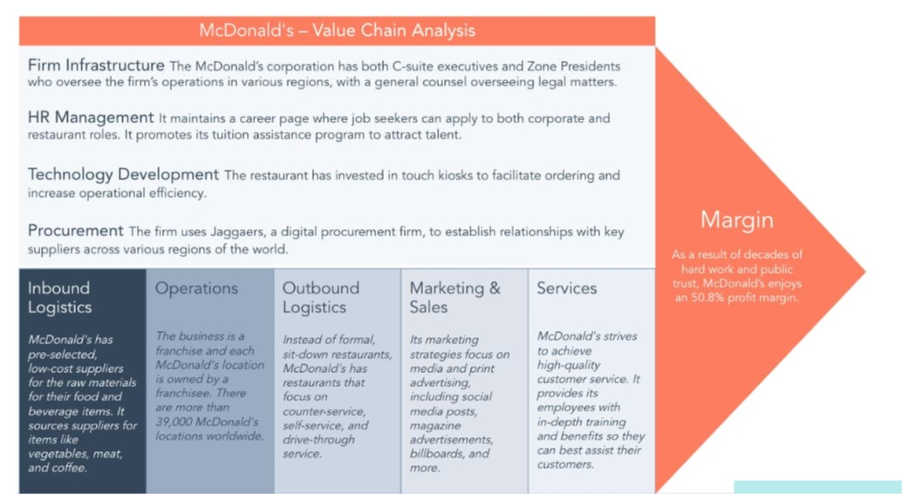

### ****Primary Activities****

* **Inbound Logistics**: McDonald's has pre-selected, low-cost suppliers for the raw materials for their food and beverage items. It sources[**suppliers**](https://www.mcdonalds.com/us/en-us/about-our-food/meet-our-suppliers.html) for items like vegetables, meat, and coffee.
* **Operations**: The business is a franchise, and each McDonald's location is owned by a franchisee. There are more than[**39,000 McDonald's locations**](https://www.entrepreneur.com/franchises/mcdonalds/282570) worldwide.
* **Outbound Logistics**: Instead of formal, sit-down restaurants, McDonald's has restaurants that focus on counter-service, self-service, and drive-through service.
* **Marketing and Sales**: Its marketing strategies focus on media and print advertising, including social media posts, magazine advertisements, billboards, and more.
* **Services**: McDonald's strives to achieve high-quality customer service. It provides its thousands of employees with in-depth training and benefits so they can best assist their customers.

### ****Support Activities****

* **Firm Infrastructure**: The McDonald’s corporation has both C-suite executives and Zone Presidents who oversee the firm’s operations in various regions, with a general counsel overseeing legal matters.
* **Human Resource Management**: It maintains a[**career page**](https://careers.mcdonalds.com/main/) where job seekers can apply to both corporate and restaurant roles. It pays hourly and salaried rates and promotes its tuition assistance program to attract talent.
* **Technology Development**: The restaurant has invested in touch kiosks to facilitate ordering and increase operational efficiency.
* **Procurement**: The firm[**uses Jaggaer**](https://www.jaggaer.com/app/uploads/2020/10/CS_McDonalds_EN-US-1.pdf), a digital procurement firm, to establish relationships with key suppliers across various regions of the world.

**------------------------------------------------------------------------------------------------------------------------------------------------------------------------------------------------------------------------------------------------------------------------------------**